**Created a method name getrecord():**

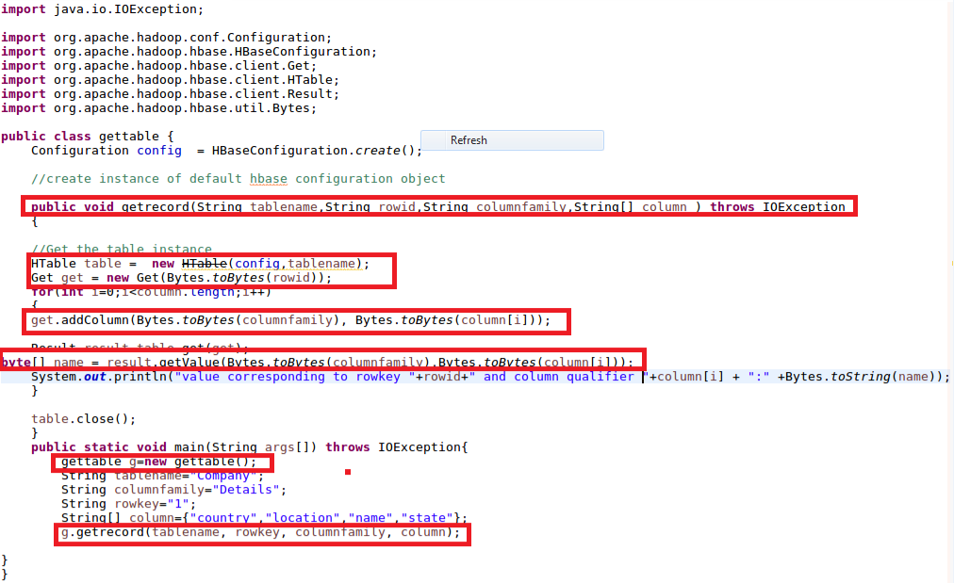

**Output:**

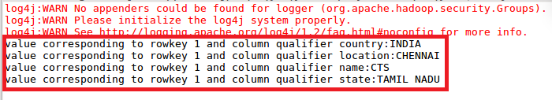

**Create the method name display:**

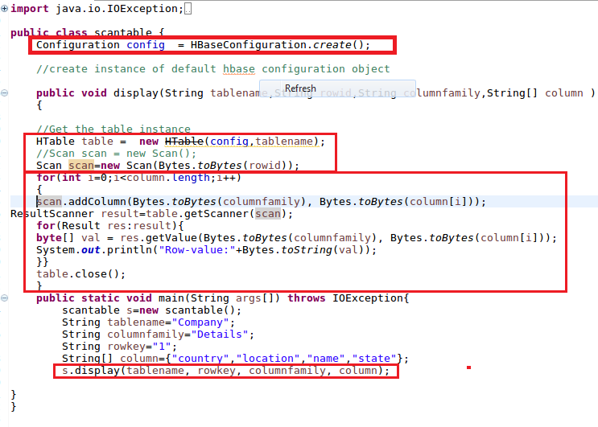

**Output:**

